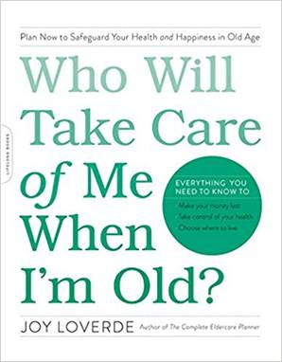

BEAT THE ODDS TO AGE IN PLACE CHECKLIST
Who Will Take Care of Me When I’m Old?

Make a list the following:

Financial challenges of aging in place:
________________________________________________________________________________________________________________________________

Social challenges of aging in place:
________________________________________________________________________________________________________________________________

Service challenges of aging in place:
____________________________________________________________________________________________________

Location challenges of aging in place:

________________________________________________________________

Check off the following tasks upon completion:

I have explored resources to manage the financial challenges.

I have explored resources to manage the social challenges.

_____ I have explored resources to manage the service challenges.

_____ I have explored resources to manage the location challenges.

_____Financial challenges are resolved.

_____Social challenges are resolved.

Services challenges are resolved.

_____ Location challenges are resolved.

_____ I have determined that I can age in place and have reviewed the chapter
in this book called “Bring Livability Home,” which begins on page 103.

_____ I understand that my current housing will not serve me in the long run, and
have reviewed the chapter in this book titled “Moving On,” which begins on
page 119.

