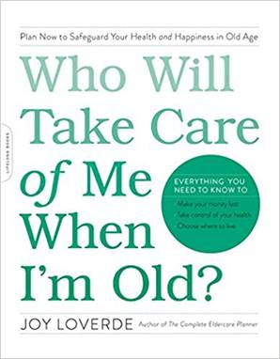

MANAGE CHANGE WORKSHEET
Who Will Take Care of Me When I’m Old?

Changes—big and small—can happen at any time. Use this guide to get clearer about the big picture and to ease into the transition process.

In time, what you write about today, with the help of this worksheet, will serve as a stepping stone to managing future challenges.

Let your answers to the following questions sink in. These are tough questions. Be kind to yourself. You deserve time and space to heal.

The Situation

Define life before the change
________________________________________________________________________________________________________________________________

Define life after the change
________________________________________________________________________________________________________________________________

What am I saying good-bye to?
________________________________________________________________________________________________________________________________

What am I saying hello to?
________________________________________________________________________________________________________________________________

How will the change negatively impact me?
________________________________________________________________________________________________________________________________

How will the change positively impact me?
________________________________________________________________________________________________________________________________

Who besides me is affected by this change?
________________________________________________________________________________________________________________________________

How will the change affect me a year from now?
________________________________________________________________________________________________________________________________

In what way has this change altered my assumptions?
________________________________________________________________________________________________________________________________

Looking back, what were the clues that this change was inevitable?
________________________________________________________________________________________________________________________________

The Transition

How am I feeling right now?
________________________________________________________________________________________________________________________________

What am I not in control of now?
________________________________________________________________________________________________________________________________

What am I in control of now?
________________________________________________________________________________________________________________________________

What don’t I understand or am still confused about?
________________________________________________________________________________________________________________________________

What am I impatient and anxious about?
________________________________________________________________________________________________________________________________

What are my greatest fears regarding this change?
________________________________________________________________________________________________________________________________

What am I resisting and resenting about this change?
________________________________________________________________________________________________________________________________

What lost opportunities am I ashamed, angry, sad, or remorseful about?
________________________________________________________________________________________________________________________________

What are the positive effects of this change?
________________________________________________________________________________________________________________________________

Launch of Growth and Learning

What was my role in why this change took place?
________________________________________________________________________________________________________________________________

Which personal relationships are doing me more harm than good right now?
________________________________________________________________________________________________________________________________

Which professional relationships are doing me more harm than good right now?
________________________________________________________________________________________________________________________________

What advice would I give a good friend who is going through a similar situation?
________________________________________________________________________________________________________________________________

Who was I before this change occurred?
________________________________________________________________________________________________________________________________

What are some creative ways to say good-bye to the “old me?”
________________________________________________________________________________________________________________________________

What will it take for me to accept that I may never completely understand or accept this change?
________________________________________________________________________________________________________________________________

Overall, what is the lesson in all this?
________________________________________________________________________________________________________________________________

How will I grow from this experience?
________________________________________________________________________________________________________________________________

What new opportunities are available to me now?
________________________________________________________________________________________________________________________________

What is one thing I can realistically do right now during this stage of the transition?
________________________________________________________________________________________________________________________________

Who can I lean on for support during this transition?
________________________________________________________________________________________________________________________________

