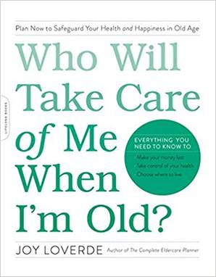

RISKY BUSINESS WORKSHEET
Who Will Take Care of Me When I’m Old?

Today’s Date:

Desired Decision Date:

The decision I am attempting to make:
________________________________________________________________________________________________________________________________

Every decision has its pros and cons. Fill in the following “Pros” and “Cons” columns as best you can. Making a list of what works and what doesn’t will help you gain a clearer perspective of the situation.

Consider the following when composing your Pro and Con lists:

The effects of the decision on physical and emotional health
Whether the decision puts others at risk, and the extent of those risks
Whether the decision is irreversible or can be modified later on
The potential consequences of the decision
If the timing is right to be making the decision
Whether existing resources are adequate
The financial implications of the decision
How much the decision will matter in a year from now

Pro’s Cons

How did the pros and cons stack up? Did other concerns surface that require your immediate attention before you can make a final decision? If yes, create a plan of action to get those challenges resolved.

There is one more task before you make your decision, and that is to let your body weigh in. Put up a “do not disturb” sign. Take fifteen minutes. Close your laptop, silence your phone, close your eyes, and turn inward.

Is your body calling out a warning or is it telling you that you are going in the right direction? What are you sensing? What are you visualizing? What are you feeling?

When you are ready to make your final decision, write it down.

My decision is: ________________________________________________________________________________________________________________________________________________________________________________________________
________________________________________________________________

