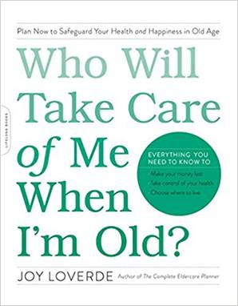

TIE UP LOOSE ENDS WORKSHEET
Who Will Take Care of Me When I’m Old?

The clock is ticking. Keep that in mind as you review the list below. Finish the sentences, then create an action plan to carry out your desires:

Things I want to start but haven’t started
________________________________________________________________________________________________________________________________

Things I want to change but haven’t changed
________________________________________________________________________________________________________________________________

Things I want to stop but haven’t stopped
________________________________________________________________________________________________________________________________

Things I started but haven’t finished
________________________________________________________________________________________________________________________________

Things I want to do but haven’t done
________________________________________________________________________________________________________________________________

Things I want to say but haven’t said
________________________________________________________________________________________________________________________________

Things I want to learn but haven’t learned
________________________________________________________________________________________________________________________________

Things I need to return that do not belong to me
________________________________________________________________________________________________________________________________

Things I want to give away to someone while I am alive
________________________________________________________________________________________________________________________________

