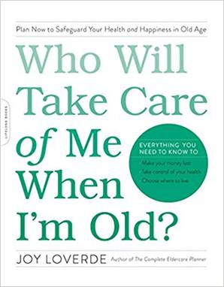

WHAT SHOULD I DO? WORKSHEET
Who Will Take Care of Me When I’m Old?

Life happens, and now you have no choice but to make a decision. Keep in mind that problem solving and decision making are two separate and distinct processes. The goal is to get better at both.

Strategic thinking takes practice. In time, confidence increases and you are less likely to rush to the first solution—which may not necessarily be the best one in the long run.

Begin by writing down the answers to the following questions on a separate sheet of paper:

What is the decision that must be made?
By when must the decision be made?
What is making this decision problematic?
What proof do I have that a problem exists?
What about this situation is within my control?
What about this situation is not within my control?

CONDUCT RESEARCH / SEEK ADVICE

Based on your answers to the questions above, conduct your own research on the problem, and possible solutions.

Next, identify three trusted and diverse sources for advice regarding your situation. Seek people you know both personally and professionally. Make a date to connect with them.

Before connecting with advisers, be prepared to take notes or ask for permission to record the meeting. Also come prepared to discuss in detail the decision that must be made and related challenges.

During your meeting with advisers, take notes. Write down their questions as well. Ask your advisors…

What is your perspective?
Why do you think this way?
What is your evidence for your beliefs?
What are the short- and long-term impacts of the problem?
What are the worse- and best-case scenarios?

After consulting with advisers, ask yourself the following questions:

Are there similarities in my advisers’ answers?

Are there any significant differences of opinion or approach?

Are there multiple alternative solutions to the problem?

Do I have a new and different perspective on the problem and the decision?

Do I need to redefine the problem?

Before you decide what to do, also consider these questions:

Is this the right time to make this decision?
What are the likely consequences if I decide to delay the decision?
Who else is affected by my decision? Must they be consulted before or after I decide?
What are the needs of those who will be affected by this decision?
Will this decision have a negative effect on my physical or emotional well-being?
Will this decision alter my personal or professional relationships?
Have I researched all costs and who pays for what?
Am I being honest with myself or am I engaging in wishful thinking?
Do I have time to make adjustments if things don’t work out?
What is my gut instinct telling me to do?

When you are ready or at a “good enough” position, make a decision.

This is what I will do, and why:
________________________________________________________________________________________________________________________________________________________________________________________________

Make a plan that defines a sequence of events and action steps necessary for
completion.

Evaluate the results. Is the problem solved?

Recommended Reading:
Leadership Simple: Leading People to Lead Themselves (2003) by
Steve Morris and Jill Morris

Recommended TED Talk:
“The Surprising Habits of Original Thinkers,” presented by Adam Grant, filmed February 2016

