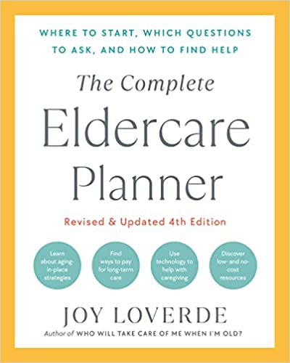
ADULT-LIVING CHECKLIST
START HERE
- If researching a care community, you may want to hire an independent patient advocate or case manager to accompany you on the tour.
- Consider whether the new location will be convenient for you and others to visit.
- Is a nursing home necessary or are there alternatives? If memory care is not offered, will your elder eventually need to move out? Discuss care options with the doctor.
- Transparency of operations has never been more important. Do not hesitate to ask for documents.
- Do not sign any agreements without reviewing documents with an attorney.
- Do not sign any agreements that include arbitration clauses that waive the right to a court hearing in the event of conflicts.
- Before deciding where to live, ask about one- or two-week trial runs.
DUE DILIGENCE RESOURCES
- Check licenses, permits, accreditation, complaints, reputation, financials, and criminal records. The community care licensing division of your state’s department of social services will inform you of whether a facility has obtained proper licenses to conduct business.
- Read through online reviews and social media comments.
- Search online to find information about the owners. Who are they? How long have they been in business?
- Contact your state’s public health office and ombudsman office, your county’s public records, and the Better Business Bureau to review reports and any formal complaints that may have been filed.

MONEY
- What are the costs? What is not included in the monthly fee? Transportation? Cable TV? Internet?
- What are the “hidden” fees (catheters, bandages, lotions, continence products, etc.)?
- Is the building currently approved and licensed for Medicaid residents?
- Do you accept long-term care insurance?
- What happens if the resident’s money runs out? Are the adult children responsible for costs?
- Are fees refundable? Under what circumstances?
- Are there move-in and move-out fees?
- Who calculates care costs? What is the system for determining care costs?
- Have you ever filed for bankruptcy? Are you currently operating at a profit?
- How often do you increase rates? What percent? When was the last rate increase?
- Do you have anything in writing that defines what happens if you close your doors?
- Are there any move-in incentives or upcoming specials available?
- Which fees are negotiable?
- Can services be purchased “à la carte,” or are they all-inclusive?
- Are there cost adjustments for couples if one person is relocated to a health-care unit?
- Will you show me your financial statements? (Look for reserves, income, and cash flow.)
STAFF
- What are your staff qualifications and licenses?
- What’s the staffing level during the day versus at night and weekends?
- What is the staff-to-resident ratio?
- What is the availability of a medical doctor (MD)? A licensed practical nurse (LPN)? A registered nurse (RN)?
- What is the staff turnover rate?
- What is the average length of staff employment?
NURSING DIRECTOR QUESTIONS
- What is the highest level of care offered?
- Can residents age in place when they need higher levels of care?
- Do you separate couples if one requires a higher level of care?
- Under what conditions do you move residents from room to room?
- Can residents hire their own caregivers?
- Who decides when a resident requires more care?
- What are the checks and balances to assure that everything is being done correctly?
- How many hours of care are you licensed to provide each resident?
- What hospital will a resident be taken to if care is needed?
- Tell me about your continence care program. How is your staff trained?
- How do you prevent pressure sores in this facility?
- Are you certified for the Montessori Inspired Lifestyle for memory care?
- What are the physical and chemical restraint and bed-rail policies?
- What is the process for observing advance medical directives and do-not-resuscitate (DNR) orders?

LIFE PLAN COMMUNITY
- What do you do with the entrance fee?
- What is your occupancy percentage? (Look for a 90 percent rate or more.)
- How will future expansion and refurbishing building plans affect costs?
- Do you have a home- and community-based services program?
- Do you have a future-residents club? What are the privileges of becoming a member?
WELLNESS AND ACTIVITY DIRECTOR QUESTIONS
- Do you have a gym on-site?
- Is the wellness program personalized for each participant?
- How does the wellness program allow opportunity for mastery (not just participation)?
- How many of the programs are resident-run?
- Do residents have a choice in when they can participate in programs?
- How do programs support social connections both within and beyond programs?
- What is offered in terms of intergenerational activities?
- Are customized menu options offered? Are there gluten-free or vegan options?
- How are residents’ cultural, spiritual, and emotional needs met?
- How do you connect with external influences (neighborhood initiatives)?
EVACUATIONS, EVICTIONS, AND DISCHARGE
- How long is an apartment held if a resident is hospitalized or sent to rehab?
- On what grounds can a resident be evicted?
- Is obesity grounds for eviction?
- Is running out of money grounds for eviction?
- What is your rehousing policy should there be a need to evacuate residents from the premises?
- Are your eviction and discharge policies in writing? I would like to have a copy of this document.
HOUSE RULES AND OPERATIONS
- Is recreational and medicinal use of cannabis use allowed? Smoking? Alcohol consumption?
- What is the pet policy?
- What is your policy and privacy procedure about sex between two consenting adults?
- What is your anti-bullying policy? Are your antidiscrimination policies in writing? May I have a copy of these policies?
- Do you have an active resident and family council? Support groups?
- How are family members kept informed?
- How often do residents file theft reports?
- Is every room air conditioned?
- What is your weather- and fire-related disaster plan?
- What is your policy about residents having security cameras installed in their room?
INFECTION CONTROL
- As of today, how many people have died at your community from COVID-19?
- How do you protect residents and staff from COVID-19?
- Do you screen visitors for COVID-19? (If there is no screening process, take this housing option off your list.)
- What are your lockdown and quarantine policies and procedures?
- Under what circumstances do you prohibit visits from family member?
- Do you ban residents from leaving the property for outings with family and friends?
ASK FOR WRITTEN DOCUMENTATION (SIGN NOTHING)
- Financial statements and legal agreements
- General operating procedures
- Eviction policies and procedures
- Inspection reports
- Copy of their duties under the Nursing Home Reform Act
ON-SITE OBSERVATIONS
- Are you feeling at ease? Were you warmly greeted upon entering the building?
- How do the interior and exterior look? Is the building nicely maintained?
- When touring the interior, do you smell unusual odors?
- Do residents appear to be active and engaged? Are they well cared for?
- Do you see staff demonstrating safety and cleanliness?
- Ask residents about their experiences.
- Talk to visiting family members.

