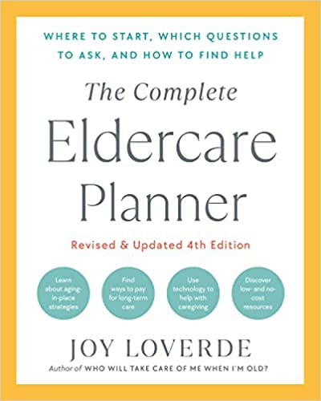

DEATH AND DYING ACTION CHECKLIST

SAYING GOODBYE To Do By Completed
Recognize the clues of letting go ________________ ❏

Be aware of your elder’s goal to reach milestones
family events ________________ ❏
important projects ________________ ❏
personal goals ________________ ❏
Spend quality time ________________ ❏
Seek professional counseling ________________ ❏

Discuss end-of-life directives
nutritional and respiratory life support ________________ ❏
funeral arrangements ________________ ❏
memorial services arrangements ________________ ❏
power of attorney for health care ________________ ❏
physician directives ________________ ❏
review Managing Death’s Details section ________________ ❏
review “Legal Matters” chapter ________________ ❏

Get legal papers in order ________________ ❏
Fulfill last wishes ________________ ❏
Manage pain issues ________________ ❏
Consider hospice services ________________ ❏
Review The Dying Person’s Bill of Rights ________________ ❏

MANAGING DEATH’S DETAILS

Seek professional advice for
funeral planning ________________ ❏

Review “Communicaring” chapter
before talking about funerals ________________ ❏

Incorporate plans as part of letter of
Instruction in your elder’s will ________________ ❏

Shop around for funeral merchandise
and services ________________ ❏

Tap into sources to pay for funeral
Social Security ________________ ❏
Veterans Affairs ________________ ❏
prepayment plans ________________ ❏
life insurance policies ________________ ❏
burial trusts ________________ ❏
savings accounts ________________ ❏
travel insurance ________________ ❏
house sale ________________ ❏

Notify others of the death
email ________________ ❏
telephone ________________ ❏
death notice ________________ ❏
obituary ________________ ❏

Gather legal and important documents ________________ ❏
Retain attorney ________________ ❏
Obtain copies of death certificates ________________ ❏
Review “Access Now” chapter ________________ ❏
Explore sources of leftover cash ________________ ❏
Inquire about survivor benefits ________________ ❏
Review travel insurance policies ________________ ❏
Understand transfer of
property regulations ________________ ❏
Begin probate process ________________ ❏
Obtain letters of office ________________ ❏
Settle financial affairs ________________ ❏
Search for missing information
and documents ________________ ❏

Tie up loose ends
distribution of items ________________ ❏
lock up property ________________ ❏
keep record of all transitions ________________ ❏

Grieve and heal
watch for excessive behavior patterns ________________ ❏
consider bereavement support ________________ ❏

Carry on after the caregiving ends
repair damaged relationships ________________ ❏
create new relationships ________________ ❏
seek a new purpose in life ________________ ❏
make a difference in the lives of
other caregivers ________________ ❏

