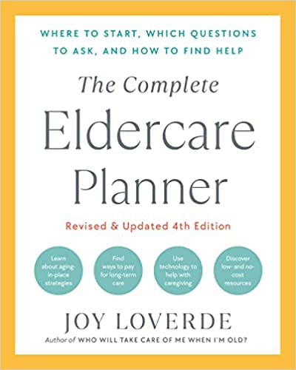

Today’s Date:

DECISION-MAKING WORKSHEET

Feeling overwhelmed with too many options and choices? Use this worksheet whenever you are faced with making an important decision.

- Define the decision you need to make. Base your statements on facts, not assumptions or wishful (or fearful) thinking.

The decision I am contemplating is:

- Consider the pros and cons to see how the benefits and disadvantages stack up. Ask yourself these questions when writing down your pros and cons:
- Is this the right time for this decision or is it better to wait?
- Who else can shed light on this decision?
- Do I fully understand the answers given by the professionals?
- Do I have all of the information needed to weigh the potential consequences?
- What are the needs and wants of those who will be affected by this decision?
- What is the extent of my obligations toward the people involved in this decision?
- How might this decision negatively affect my physical and emotional health?
- Will I put others at risk or hurt anyone with this decision?
- How might my personal relationships change for the worse?
- What is the best that can happen and what is the worst that can happen?
- Have I researched all costs and who pays for what?

THE PROS ARE:

THE CONS ARE:

- Review the pros and cons. Does one list outweigh the other?

If the potential decision involves legalities such as contracts and considerable costs, get professional advice.

If the decision impact your elders, involve them in the decision-making process.
Insist on family meetings and discussions as a way to keep everyone involved and accountable.
- The two most important facts in the pros column are:
- The two most important facts in the cons column are:

BASED ON THE PROS AND CONS, MY DECISION IS:

