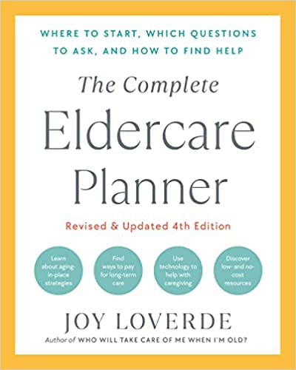
DOCTOR APPOINTMENT CHECKLIST

BEFORE THE DOCTOR APPOINTMENT
Confirm:
- The appointment day and time (add to elder’s and your own calendar)
- The purpose of the appointment
- Lab results have been received and reviewed by the doctor’s office
Gather the following:
- Proof of health insurance
- Driver’s license or state ID
- Medical history, surgeries, and current list of medications (see pages 000–000)
- Past test results and X-rays (mammograms, colonoscopies, blood tests, etc.)
- Proof of vaccinations and boosters
- List of allergies
- List of past and current health-care providers
- Health or fitness tracker documentation of daily habits
- Emergency contact information
- Note-taking devices (use a note-taking app on a smartphone or paper and pen, or ask permission to record the session)
Prepare to discuss:
- Current medical conditions
- New symptoms
- Pain location, history, and level (on a scale of 1 to 10, with 10 being most intense)
- What the pain feels like (piercing, aching, burning, throbbing?)
- Changed symptoms since the last appointment
- Questions to ask the doctor
- Recent hospitalizations
- Major life stressors (such as worries about money or recent deaths of loved ones)
- Family medical history
Inform the doctor’s office of any needed accommodations:
- Accessible parking
- Wheelchair assistance
- Help of an interpreter or translator
Prepare for telemedicine appointments:
- Use the best camera you can find. This may be attached to your phone, laptop, tablet, or desktop computer. Test the camera in advance.
- Test the sound and video on the device.
- Test the internet connection.
- Make sure the device is charged.
- Find a quiet space and adjust lighting. Limit distractions.

DURING THE DOCTOR APPOINTMENT
Be prepared to ask questions and take notes on the following:
- Ask for the definition of unfamiliar medical terms.
- Repeat what is being said in your own words to avoid misunderstandings.
- Ask about the cause of the illness.
- Ask about the doctor’s experience in treating the illness.
- Ask for copies of medical records, charts, and test results.
- Ask if there is a choice in hospitals if surgery is recommended.
- Ask about potential short-term and long-term lifestyle modifications.
- Ask about related costs.
Ask these questions if tests are recommended:
- What specifically do you hope to accomplish with this test?
- What are the risks involved with taking this test?
- Can you describe the actual procedure?
- What is the likelihood of inaccurate test results or false positives?
- What pretest preparations are necessary?
- When and how will the test results be communicated?
Look for clues that older patients are in good hands:
- Is the elder acknowledged respectfully and attended to?
- Are they allowed enough time for explanations and questions?
- Are they listened to no matter how busy the staff is?
- Is the elder offered an individualized plan of care?
- Does the elder feel empowered to make choices and decisions?

