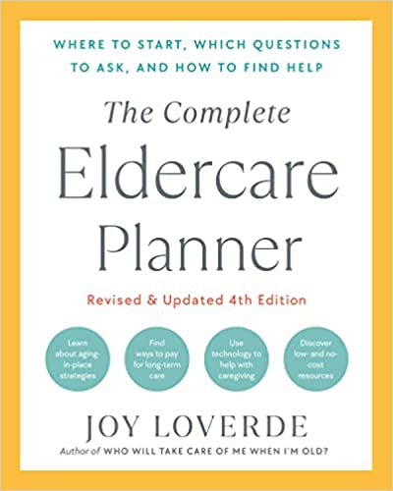

Today’s date

ELDER EMERGENCY INFORMATION CHART

Elder’s name (first, middle, last)
Elder’s maiden name
Address/Apartment Number
City/State/Zip
Telephone—home
Telephone—work
Telephone—mobile
Date of birth
Place of birth
Driver’s license number and state issued
Auto make, model, and license plate number
Social Security number
Medicaid
Medicare number
Medicare supplement number
Medicare drug plan
Do not resuscitate (DNR) order in effect?
Do not intubate (DNI) order in effect?
Do not hospitalize (DNH) order in effect?

Food allergies
Other allergies
Blood type
Power of attorney for health care
Power of attorney for finances

Current medications
Vaccinations and boosters
Advance directives
Dementia advance directives
Religious preferences

