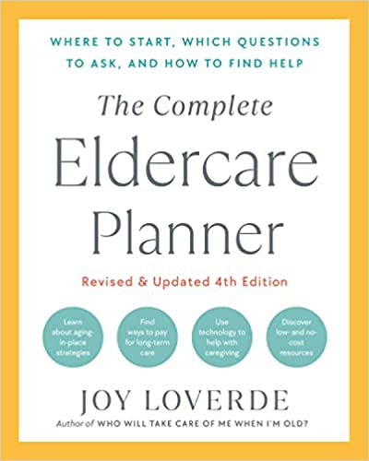
Today’s Date:

HIRING IN-HOME HELPERS CHECKLIST
Applicant’s Name:
Address/Apartment Number
City/State/Zip:
Cell Phone:
Referring Agency:
Agency Contact Information:

Ask the applicant:
- What makes you interested in this kind of work?
- Tell me about your past work experience.
- Why did you leave your last position?
- Are you in this country legally? (Ask for proof.)
- What is your COVID-19 vaccination and booster status?
- Will you follow COVID-19 safety protocols? What are they?
- Will you wear a mask for the entire time you are working?
- Have you received any special training?
- Do you have any problems that might hinder you in this job?
- How do you feel about alcohol, drugs, and smoking?
- Are there any tasks you would not be willing to do? (Laundry? Cooking?)
- What is your time commitment to this position?
- Do you have a current driver’s license?
Ask the agency:
- Are you licensed and accredited? By whom?
- Is your agency bonded? Is your worker bonded?
- Who pays insurance and taxes and handles employer responsibilities?
- How long have you been in business?
- Do you accept Medicare?
- Do you offer sliding-scale fees?
- What are the fees for services provided by your worker?
- What costs are not covered?
- Who pays the worker - you or me?
- What are the minimum and maximum hours of service?
- Are there limits to services provided?
- What is your screening process when hiring workers?
- How do you supervise your workers?
- Is the worker specially trained to work with older adults?
- Do you find a replacement if your worker is ill or on vacation?
- Do I continue to pay your worker while my elder is in the hospital?
- Can your agency provide me with references for you and your worker?
- What is the process when a worker does not show up for work?
- How soon can a worker begin?

Ask the reference:
- How long have you known this applicant?
- What was the applicant’s position and job description?
- Why did the applicant leave your employment?
- How well did the applicant get along with others?
- What were the applicant’s strengths? Weaknesses?
- Did you find the applicant trustworthy?
- Were you aware of any substance abuse? Smoking?
- Would you rehire the applicant?
- (Describe the job you have in mind.) Is the applicant well suited for the job?

Ask yourself:
- Do I really believe this person is right for the job?
- Will this person take charge and respond quickly in an emergency?
- Is this person organized? Neat? Flexible? Energetic? Pleasant?
- Does this person have the proper training and experience for this job?
- Will this person get along with my elder? Family? Others?
- Will this person know when to consult the family?
- Will this person be sensitive to family traditions?
- Does this person do okay with pets if one is in the household?
- Do family members like and trust this person?
- Do family members believe this person can handle this job?

