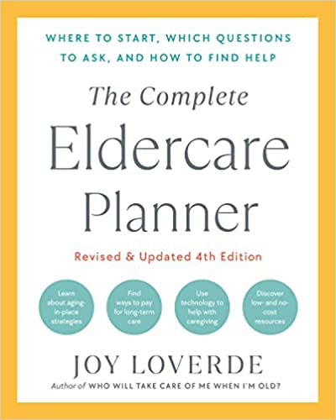

HOUSING ACTION CHECKLIST

MOVE OR STAY PUT? To Do By Completed

List circumstances for possible
change in housing ________________ ❏

Set housing goals
short-term ________________ ❏
long-term ________________ ❏

Determine home modifications
short-term ________________ ❏
long-term ________________ ❏

Check laws and codes for
home modifications ________________ ❏

Research loans and funds for
home modification plans ________________ ❏

Research realtors to
sell the family home ________________ ❏

Review housing options
age in place ________________ ❏

life plan community ________________ ❏

assisted living ________________ ❏

memory care ________________ ❏

skilled-nursing care ________________ ❏

LBGTQ+ housing ________________ ❏

affordable housing ________________ ❏

age-qualified rental apartments ________________ ❏

home-sharing ________________ ❏

naturally occurring retirement
community (NORC) ________________ ❏

Village-to-Village ________________ ❏

residential assisted-living homes ________________ ❏

active adult community ________________ ❏

