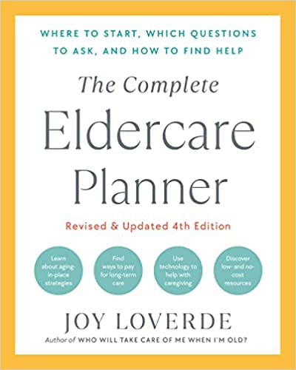
MANAGING MEDICAL CARE ACTION CHECKLIST

PARTNERSHIP FOR QUALITY HEALTH CARE To Do By Completed
Create a plan if your elder refuses medical help ________________ ❏
Get HIPAA authorization from elder ________________ ❏
Become familiar with health-care professions ________________ ❏

Take active role in health care for better service
Help elders track the pain ________________ ❏
Put everything in writing ________________ ❏
Prioritize health issues ________________ ❏
Conduct research ________________ ❏

Check medical staff board certifications
and licenses ________________ ❏
Make plans to accompany elders
to medical appointments ________________ ❏

Prepare for doctors’ appointments
medical history ________________ ❏
dental history ________________ ❏
medication history ________________ ❏

Verify appointment in advance ________________ ❏
Consider a second opinion when applicable ________________ ❏

Switch doctors if unsatisfied ________________ ❏
Consider technology to assist with
in-home health care ________________ ❏
Pay attention to elderly dental care ________________ ❏
Gather and store personal medical records ________________ ❏
Manage medical bills ________________ ❏

Obtain contact information for
doctor ________________ ❏
dentist ________________ ❏
health-care providers ________________ ❏
emergency contact information ________________ ❏
pharmacy ________________ ❏
hospital ________________ ❏
health insurance ________________ ❏

Keep important phone numbers
immediately accessible ________________ ❏
Distribute phone numbers to
key family members ________________ ❏

PATIENT CARE: IS SPIRITUALITY GOOD MEDICINE?

Assume personal responsibility for own
spiritual beliefs and professional practices ________________ ❏
Learn the spiritual and religious wishes
of your elders ________________ ❏

Help your elder to complete the
“Spiritual History Questionnaire”
attach a copy of the document to
your elder’s medical/medications history ________________ ❏
distribute copies to other family members ________________ ❏
ask the doctor’s office to file a copy
with your elder’s medical records ________________ ❏
attach a copy to all medical charts
when entering a health-care facility ________________ ❏

Access spiritual resources in the health-care setting
Clergy ________________ ❏
hospital chaplain ________________ ❏
community clergy and lay volunteers ________________ ❏
interfaith chapel ________________ ❏
religious services ________________ ❏
parish nurse ________________ ❏
seminars and support groups ________________ ❏
palliative care and hospice ________________ ❏
physician ________________ ❏

