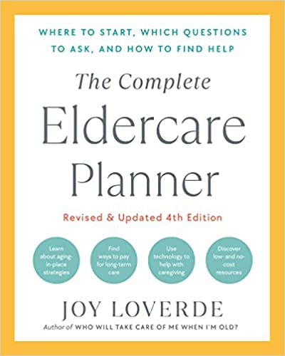

PROFESSIONAL ADVOCATE QUESTIONNAIRE
- How are you qualified to do this work?
- What degrees do you hold?
- Where did you work prior to entering private practice? For how many years?
- How long have you been in business?
- Is this a full-time or a part-time practice?
- Are you certified? Licensed? Bonded?
- What are your hours and availability in an emergency?
- What are your emergency backup plans if you’re unavailable?
- Who supervises your work?
- How much do you charge for an initial assessment?
- What is your hourly fee?
- What can I expect to pay? What is your billing cycle?
- What are the range of services you provide?
- What is your role once a referral is made?
- How, and how often, will you update me?
- May I have the name of three references who have used your service?

