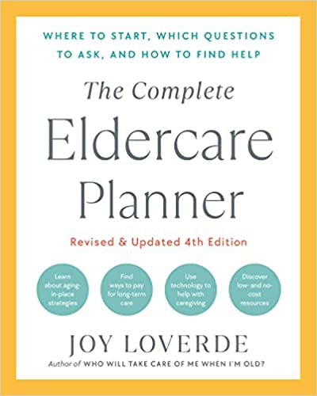

QUALITY OF LIFE ACTION CHECKLIST

WHAT’S AGE FOR, ANYWAY? To Do By Completed

Be aware of roadblocks to quality of life
chronic pain ________________ ❏
depression ________________ ❏
illness ________________ ❏
alcohol abuse ________________ ❏
medication and drug abuse ________________ ❏
suicidal tendencies ________________ ❏

Ask life-enriching questions _________________ ❏

Tap into age-friendly resources
Travel ________________ ❏
learning centers ________________ ❏
fitness centers ________________ ❏

Suggest employment options
and volunteer opportunities _________________ ❏
Facilitate spiritual and religious needs _________________ ❏

Access local resources
community centers ________________ ❏
adult education centers ________________ ❏
religious congregations ________________ ❏
support groups ________________ ❏
FAMILY POWER
Capture special caregiving moments _________________ ❏
Create opportunities for reminiscing ________________ ❏
Research family history _________________ ❏
Use technology to capture
special moments _________________ ❏

Keep family customs, traditions,
and rituals alive _________________ ❏

Learn more about your family roots
draw a family tree _________________ ❏
conduct library research _________________ ❏
search family records _________________ ❏
conduct interviews _________________ ❏
inquire about possessions _________________ ❏
explore attics _________________ ❏
accompany your elders back to
their hometowns _________________ ❏

Plan on giving meaningful
and memorable gifts _________________ ❏

Foster the grandparent
and grandchild connection _________________ ❏

Create opportunities for elders to
contribute back to the family _________________ ❏

