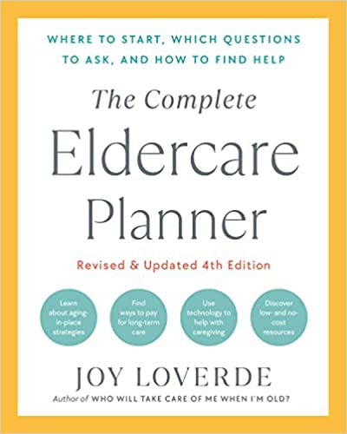

SPIRITUAL HISTORY QUESTIONNAIRE

BELIEFS AND PRACTICES
Is spirituality, faith, and/or religion important to you?
Are you a member of a particular religious organization or spiritual community? If yes, which one?
Name the particular individual counselor or member of the clergy you would want to be contacted.
TREATMENT OF ILLNESS
Do you hold any spiritual or religious beliefs that might interfere with or impact your medical care? If yes, what are they?
Do you engage in any cultural practices that might interfere or conflict with your medical care? If yes, what are they?
How would you like your health-care provider to address your spiritual, religious, and/or cultural practices?
In the face of a terminal illness, how do your beliefs and culture influence end-of-life medical issues and decisions?
SUPPORT SYSTEMS
What are your main religious and/or spiritual support systems?
What activities do you participate in to help you maintain your religious and/or spiritual practices?
Do you have a group of like-minded friends who can serve as your support system?
What religious and/or spiritual support would you like right now?

