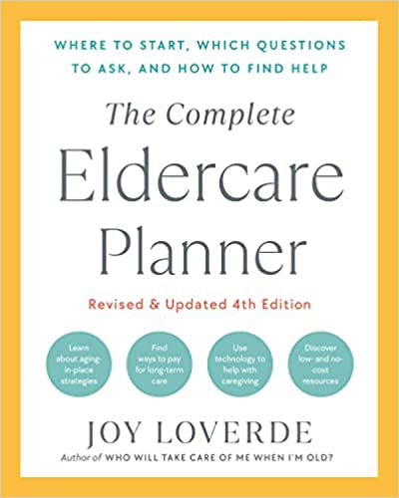
TRANSPORTATION AND MOBILITY ACTION CHECKLIST

MEETING TRANSPORTATION NEEDS To Do By Completed

Implement driver safety precautions
arrange physical exams ________________ ❏
review medications ________________ ❏
purchase driving enhancement items ________________ ❏
discuss safe-driving habits ________________ ❏
suggest driver assessment ________________ ❏
maintain auto working condition ________________ ❏
proper insurance in place ________________ ❏

Monitor elder’s ability to drive safely ________________ ❏

Prepare for driving-related conversations ________________ ❏

Suggest transportation options
family and friends ________________ ❏
professional drivers ________________ ❏
rideshare ________________ ❏
carpool ________________ ❏
volunteer ________________ ❏
health-care transport services ________________ ❏
walk ________________ ❏
public transportation ________________ ❏
adult housing with transportation services ________________ ❏
Lessen the need for elders to drive ________________ ❏
Minimize isolation and inactivity ________________ ❏
Know the signs of at-risk driving ________________ ❏
Implement intervention support if all else fails ________________ ❏

Know phone numbers of
auto insurance ________________ ❏
auto club ________________ ❏
motor vehicle department ________________ ❏

Obtain copy of your elder’s
auto insurance card ________________ ❏
auto club card ________________ ❏

PUTTING ABILITY BEFORE DISABILITY

Gain a healthier perspective
review insights list ________________ ❏

Lessen the negative impact of a chronic illness
access health-care professionals ________________ ❏
research medical advances ________________ ❏
separate medical problems from
psychological problems ________________ ❏
seek professional counseling ________________ ❏
join a support group ________________ ❏
review the “Money Matters” chapter ________________ ❏

Help your elder maintain an independent lifestyle
medical goals ________________ ❏
psychological goals ________________ ❏
access to professionals ________________ ❏
environmental barriers removed ________________ ❏
mobility issues ________________ ❏
transportation issues ________________ ❏
elder role models ________________ ❏

Make use of independent-living products ________________ ❏

Investigate older-traveler outfitters ________________ ❏

Exercise travel precautions
keep cell phone and charger handy ________________ ❏
consider trip cancellation insurance ________________ ❏
make copies of the trip itinerary ________________ ❏
distribute trip details to family members ________________ ❏

Make special travel provisions
air travel ________________ ❏
medical needs ________________ ❏
accommodations ________________ ❏
lodging ________________ ❏

